Hirudinaria granulosa:

1. Habit and Habitat
Hirudinaria granulosa is a common Indian leech found in freshwater tanks, ponds, lakes, swamps, and slow streams. It prefers shallow water and remains concealed under weeds, logs and stones. It is sanguivorous (blood-sucking) sucking the blood of fishes and frogs, ands also of cattle or human beings when they enter the pond.

Leeches show a great diversity in their habits and habitat. Some species are marine, some are freshwater, while others are terrestrial. Though many species are blood-suckers (ectoparasitic) yet a large number are not ectoparasitic but are predatory and feed on worms, snails and insect larvae.

2. External Features of Hirudinaria Granulosa:

(i) Shape and Size:
The body of Hirudinaria is soft, vermiform, elongated, bilaterally symmetrical and metamerically segmented.
In a state of extension the body is dorsoventrally flattened and appears almost strap-shaped but in a state of contraction, the body becomes more or less cylindrical. The body is broadest near the posterior end, while narrowest near the anterior end. It has great power of contraction and expansion. A full grown specimen may attain the length of 30 to 35 cm.

(ii) Colouration:
The body is beautifully coloured with characteristic markings. The dorsal surface is generally olive-green and the ventral surface is orange-yellow or orange-red and the two sides bear distinct stripes of orange or yellow and black. On the dorsal side is a median longitudinal black stripe.

(iii) Segmentation:

The body of leech is divided metamerically into segments or somite’s but metamerism is much reduced and the number of segments, unlike other annelids, is fixed in leeches, they always have 33 segments or somite’s.
In case of leech the external segmentation does not correspond with the internal segmentation. But the original segmentation is obscured by secondary external annulation. Each segment is broken up externally by grooves into rings called annuli.
The first and second segments have one annulus each, the third has two annuli, segments fourth to sixth have three annuli each, segments seventh to twenty-second are broad having five annuli each, segments twenty-third to twenty-sixth have two annuli each, segments twenty-seventh to thirty-third have one annulus each & form the posterior sucker.
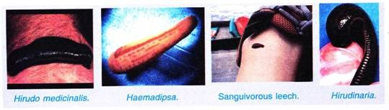
However, segments with less than five annuli are referred to as incomplete, while those with five annuli are called complete segments. Each annulus of a segment is divided into small rectangular areas by longitudinal wrinkles. Each such area has a sort of papilla-like structure bearing sensory organ called annular receptor; there are 18 such receptors both on the dorsal and ventral surfaces of each annulus.
Besides these, the first annulus of each segment bears larger sensory organs called sensillae or segmental receptors; these are four pairs on the dorsal side and three on the ventral side. Due to this the first annulus of each segment is called sensory annulus.
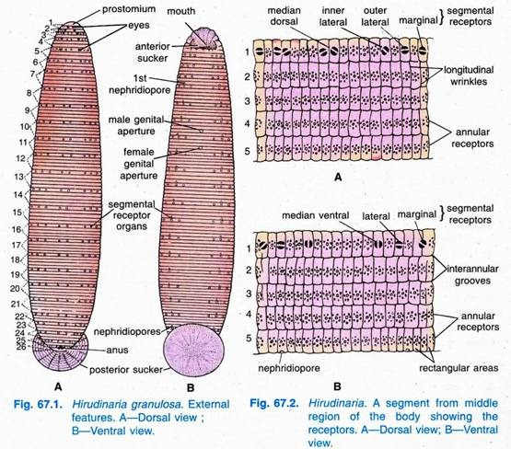

(iv) Suckers:
Each end of the body of leech bears a hollow muscular organ, the sucker. The anterior sucker or cephalic or oral sucker is formed by the fusion of the prostomium with a few somite’s of anterior region. It is oval in outline and is placed on the ventral surface of anterior end. It also possesses a ventrally directed cup-like hollow structure, the pre-oral chamber, which leads into the mouth.
The posterior sucker or anal sucker is circular in outline and forms the highly muscular disc at the posterior end of the body of leech. It is formed by the fusion of last seven segments. It is much better developed and larger in size than the anterior sucker. Both suckers are directed ventrally, the leech can firmly grip the substratum by its suckers. The two suckers are primarily meant for adhesion and locomotion.
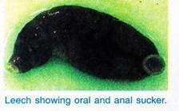

(v) Clitellum:
During breeding season a girdle-like clitellum is formed around segments ninth to eleventh, rest of the year there is no clitellum.

(vi) Eyes:
On the dorsal side are five pairs of eyes, one pair on each of the first and second segments, and one pair on the first annulus of the segments third, fourth and fifth.
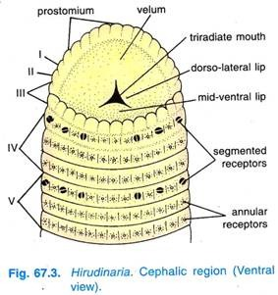

(vii) External Apertures:
External apertures in the body are as follows:
(a) Mouth:
It is a narrow triradiate aperture situated in the centre of the funnel like pre-oral chamber of the anterior sucker.
(b) Anus:
It is a very small aperture situated mid-dorsally on the twenty-sixth segment at the root of the posterior sucker.
(c) Nephridiopores:
There are seventeen pairs of nephridiopores lying on the ventral surface of the body, of which one pair lies on the last annulus of each of the segments from sixth to twenty-second.
(d) Male generative aperture:
It is situated in a groove between the second and third annuli of the tenth somite on the mid-ventral line of body. A filamentous penis is sometimes seen protruding through this aperture.
(e) Female generative aperture:
It is usually smaller and less conspicuous than the male aperture. It is situated mid-ventrally in a groove between the second and third annuli of the eleventh somite of the body.

Divisions of Body of Hirudinaria:
The body of leech is composed of 33 somite’s and is divisible into the following six regions:
1. Cephalic or Head Region:
It is composed of the first five segments. It includes the prostomium, anterior sucker, the mouth and the eyes; in fact a pair of eyes are situated on the dorsal side of first annulus in all the cephalic segments. Therefore, these segments are also referred to as the ocular segments.
Nephridiopores are absent in this region. The first two segments are uniannulate, the third segment is biannulate and fourth and fifth segments are triannulate. The prostomium and the first three segments form the upper lip.
2. Preclitellar Region:
It includes three segments, i.e., VI, VII, and VIII, all bearing nephridiopores. Somite VI is triannulate but the remaining two are completely quinquannulate, i.e., each with five annuli.
3. Clitellar Region:
It is composed of three complete segments, i.e., IX, X and XI. There is no permanent clitellum in Hirudinaria but temporary clitellum develops only during breeding season. This region possesses glandular wall. Nephridiopores are also present in this region, the male and female generative apertures are situated mid-ventrally on the X and XI segments respectively. The segments of clitellar region are quinquannulate.
4. Middle Region:
It is the largest region of the body and consists of eleven complete somites (XII to XXII). All the segments of this region are quinquannulate and possess nephridiopores.
5. Caudal Region:
This region is short and consists of four incomplete somites, i.e., XXIII to XXVI. Segment XXIII is triannulate but the remaining three are biannulate. Segment XXVI bears the anal aperture on the dorsal side. There are no nephridiopores.
6. Posterior Sucker:
It is composed of seven segments (XXVII to XXXIII) arranged in concentric rings and each represented by a single annulus. These seven segments are completely fused and their intersegmental furrows are greatly suppressed.

3. Body Wall of Hirudinaria Granulosa:
The body wall consists of five layers, viz., cuticle, epidermis, dermis, muscular layer, and botryoidal tissue.
(i) Cuticle:
The cuticle is the outermost, thin, delicate, transparent, colourless and moderately elastic protective covering. It is thicker slightly on the dorsal surface than on the ventral surface. It is perforated throughout by which epidermal glands open out. It is secreted by the underlying epidermis and is cast off in the form of thin transparent spreads periodically.
(ii) Epidermis:
The epidermis is a single-cell layer of hammer-shaped cells, some epidermal cell forms several kinds of unicellular tubular and pear-shaped glands, the gland cells are sunk into the dermis, they secrete mucus which covers the body.
Epidermal Glands:
Several epidermal glands are found in the epidermis are as follows:
1. Slime glands:
These are distributed all over the body and secrete slimy mucus that covers the whole body. These glands are either tubular or pear-shaped and sunken deep into the dermis. However, these glands are better developed on the dorsal surface than the ventral surface.
2. Sucker glands:
These glands are distributed only in the suckers and are clustered. These are pear-shaped in the anterior sucker, while rounded or spherical in the posterior sucker. Their secretion smoothens the surface for locomotion.
3. Prostomial glands:
These are found distributed only in the prostomium. These are pear- shaped and lie in groups. Their secretion forms plugs of the ootheca or egg-case.
4. Clitellar glands:
These glands are found distributed only in the clitellar segments, i.e., IX, X and XI. They become active only during the breeding season and are of two types the chitogenous glands and the albumen glands.
The secretion of chitogenous glands forms the wall of the ootheca, while albumen secreted by albumen glands is filled in the ootheca constituting the nourishment of the developing embryo. The chitogenous glands are situated between the circular and oblique muscles, while albumen glands lie in the longitudinal muscles in groups.
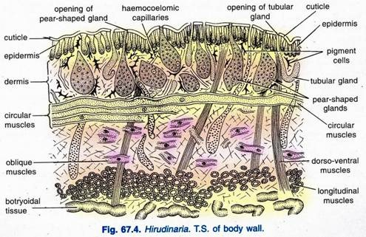
(iii) Dermis:
Below the epidermis is a dermis made of connective tissue with muscle fibres, capillaries, fat and pigment cells. The glands lie in the dermis but open on the surface.
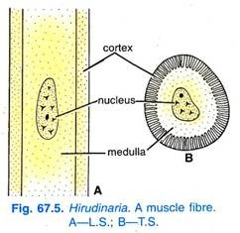
(iv) Musculature:
The musculature below the dermis has a thin layer of circular muscles and a thicker layer of longitudinal muscles. The longitudinal muscles are powerfully developed and their fibres converge into the two suckers. Circular muscles are arranged concentrically in the suckers. Between the circular and longitudinal muscles leeches have an additional double layer of oblique muscles directed spirally around the body like a coil.
There is also dorso-ventral muscles arranged segmentally throughout the body, they run from the dorsal to the ventral side in each segment.
There are some radial muscles whose fibres radiate from the alimentary canal to the skin, they take the place of septa. The muscle fibres of leech have a characteristic structure, each fibre has an outer striated and contractile cortex or myoplasm, and an inner unmodified protoplasm called medulla or sarcoplasm.
(v) Botryoidal Tissue:
The mesenchyme of leeches is a characteristic botryoidal tissue made of pigmented and richly vascularised cells which are large and arranged end to end, the cells contain a dark brown pigment and have intra-cellular branching capillaries filled with fluid.
The botryoidal tissue is probably excretory, it almost completely fills the body cavity. Within the botryoidal tissue are two types of cells characteristic of leeches, they are fat cells and yellow cells. Fat cells contain fat droplets and some glycogen, yellow cells are filled with yellow, brown, or green granules, these cells appear to be excretory.

Functions of Body Wall:

1. It protects the internal delicate organs from mechanical injury.
2. The cuticle and slimy coat check evaporation and help in easy escape from the grip of enemies.
3. It is richly supplied with haemocoelomic capillaries, hence, respiratory in function.
4. It is sensory due to the presence of various types of receptors on it.
5. The gland cells present in the wall of prostomial segment secrete plugs of the ootheca.
6. The gland cells in the clitellar segments secrete ootheca and albumen; albumen being the food of the developing embryo.

4. Locomotion of Hirudinaria Granulosa:
The leech has two types of locomotion, creeping, looping or crawling and swimming.
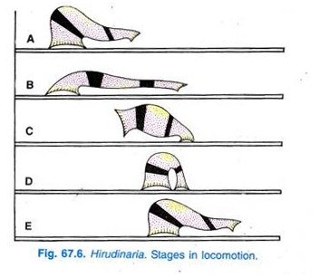

Creeping or Crawling:
In creeping the suckers are alternately fixed to the substratum and the body contracts and extends.
When the anterior sucker is fixed, a wave of contraction takes place in the longitudinal muscles shortening the animal and moving the posterior sucker forward, by this the body contracts and is pulled forwards, then the posterior sucker is fixed and a wave of contraction takes place in the circular muscles passing back from the anterior end by which the body is lengthened and extended forward.

Swimming:
In swimming a great dorso-ventral flattening takes place due to contraction of dorso-ventral muscles and undulatory waves pass in a vertical plane over the body from the anterior to the posterior end due to contraction of longitudinal muscles. The leech is a swift swimmer.

5. Digestive System of Hirudinaria Granulosa:
Digestive system consists of the alimentary canal and digestive glands associated with it.
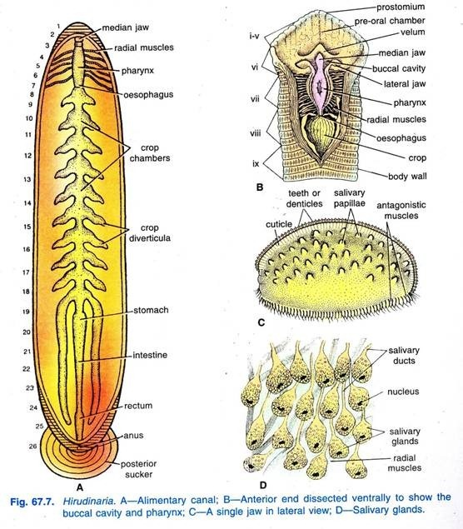

Alimentary Canal of Hirudinaria:
The alimentary canal of leech is a straight tube extending throughout the length of the body from the mouth to the anus. Leech is sanguivorous (blood-sucking) in habit, therefore, the alimentary canal is very much suited for its blood sucking habit as the most portion of the alimentary canal serves to store un-coagulated blood, while only a small portion serves for its digestion and absorption.
The alimentary canal consists of the stomodaeum (lined with ectodermal epithelium and covered by cuticle), the mesenteron (lined with endodermal epithelium and no cuticle covering) and the proctodaeum (lined with ectodermal epithelium and covered by cuticle).
1. Stomodaeum:
It consists of preoral chamber, buccal cavity and pharynx.
(i) Pre-oral Chamber:
It is a cup-shaped depression on the ventral side of the anterior sucker. At the base of the pre-oral chamber lies the tri-radiate mouth guarded by the velum, which forms an almost complete partition between the pre-oral chamber in front and the buccal cavity behind. The prostomium and the first four segments of the body form the roof of the pre-oral chamber, while the circular rim of the sucker forms its outer boundary.
(ii) Buccal Cavity:
The triradiate mouth leads into very short chamber, the buccal cavity. In the mucous membrane of buccal cavity are embedded three crescentic jaws, one mid-dorsal and the other two are ventro-lateral in position.
Each jaw is a laterally compressed cushion, covered with a fine cuticle which is thickened at the free edge to form a dentigerous ridge bearing a row of minute teeth (denticles). As these teeth form a single series on each jaw, the jaw is termed as monostichodont.
The median jaw bears 103 to 128 teeth, while the lateral jaws bear 85 to 115 teeth each. On both the sides of a jaw are small button-shaped salivary papillae, each bearing a number of openings of salivary glands. The number of papillae is 42 to 45 on each side of, a jaw. However, the jaws are moved in such a way that they make a Y-shaped wound on the body of its victim through which blood is sucked.
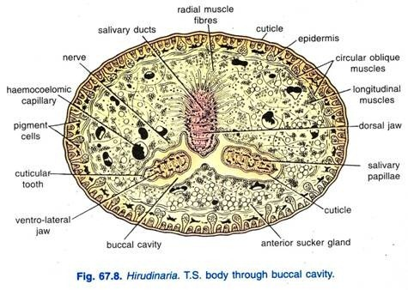
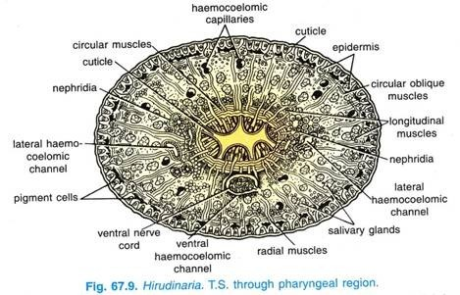
(iii) Pharynx:
The buccal cavity leads into thick-walled muscular pharynx, which is an oval sac running from the fifth to the eighth segment.
The lumen of the pharynx varies in outline in different regions. The muscles of the pharynx are circular and radial which join the pharyngeal wall to the body wall; radial muscles dilate the pharynx producing a pump-like action for sucking blood. Large masses of unicellular pyriform salivary glands surround the pharynx, their ducts open between the teeth of jaws.
The secretion of salivary glands contains a substance called hirudin or anticoagulin which prevents the coagulation of blood of the host when the leech is sucking.
2. Mesenteron:
The mesenteron consists of oesophagus, crop, stomach and intestine.
(i) Oesophagus:
It is a short narrow tube, through which the pharynx leads into the crop. The lumen of oesophagus is very narrow and its epithelial lining is produced into numerous folds.
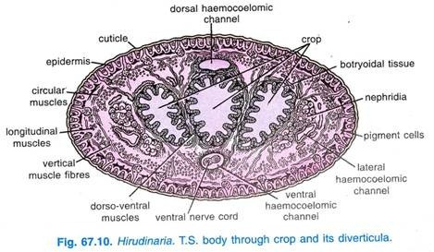
(ii) Crop:
The crop is the largest region of the alimentary canal extending from the ninth to the eighteenth segment. It has ten thin-walled chambers, one in each segment and they are connected with one another by more or less circular apertures surrounded by sphincters. Each chamber consists of a small anterior and a broad posterior part which is produced into a pair of lateral outgrowths, the caeca.
The chambers and the caeca go on gradually increasing in size towards the posterior side. The last chamber of the crop is the largest and its caeca are prolonged backwards up to the twenty-second segment. The crop and its caeca are greatly extensible and used for storing blood, one cropful of blood lasts for several months and digested slowly.
(iii) Stomach:
It is a small heart-shaped structure lying in the nineteenth segment. The opening of crop into the stomach is narrow having sphincter muscles which regulate the flow of food. The stomach has both secretory and absorptive epithelial cells and its inner lining is produced into numerous transverse folds which anastomose with one another.
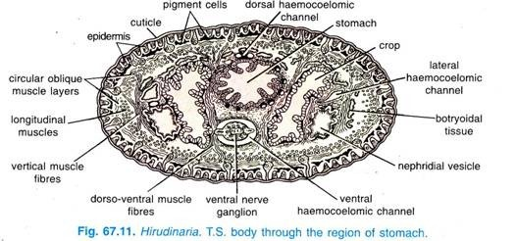
(iv) Intestine:
The stomach leads into the intestine which is not clearly differentiated externally from the stomach. The intestine is a thin-walled, straight and narrow tube extending from the nineteenth to twenty-second segment. Its inner lining is thrown into numerous longitudinal and transverse folds resembling the spiral villi to increase the absorptive surface.
3. Proctodaeum:
Proctodaeum consists of rectum only.
(i) Rectum:
The intestine opens into a short, thin-walled somewhat ciliated rectum running from the twenty-second to twenty-sixth segment. The rectum opens by a dorsal anus in the twenty- sixth segment above the posterior sucker.
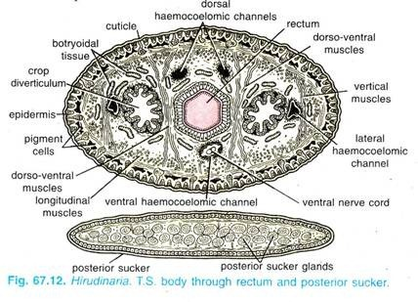
Histology of Alimentary Canal:
Histologically, the wall of alimentary canal is made of a layer of columnar epithelium resting on a basement membrane layer which is followed by the layer of connective tissue. The epithelial layer of stomodaeum and proctodaeum is lined by cuticle; it is ciliated in the proctodaeum and provided with goblet cells in the crop.
The connective tissue contains circular muscle fibres and haemocoelomic capillaries, it contains circular and longitudinal muscle fibres in the preoral chamber and in the pharynx it contains all the muscle fibres, i.e., circular, longitudinal and radial.
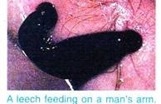

Digestive Glands of Hirudinaria Granulosa:
These include the salivary glands and some other isolated gland cells found in the mucous membrane of the gut wall.
A. Salivary Glands:
These are unicellular, pyriform, glandular mass of cells situated around and behind the pharynx.
Each glandular cell has elongated fine ductule which finally enters the jaws to open in raised salivary papillae. The secretion of these glands contains an anticoagulant substance called hirudin; hirudin prevents coagulation of blood so that the leech can suck blood effectively and for longer duration to fill up its crop and caeca.
B. Gland Cells:
These are in the form of goblet cells, found scattered throughout the lining of crop. These secrete mucus in the crop.
Food, Feeding and Digestion of Hirudinaria:
Since, leech is sanguivorous in habit, hence, it feeds on blood of cattle visiting the water source where it lives. In feeding the leech applies its oral sucker to the skin of its victim, the jaws move towards and away from each other, they painlessly puncture the skin, pump-like action of the pharynx sucks in large quantities of blood to fill the crop, secretion of hirudin prevents coagulation of blood.
In the crop, the blood is haemolysed in which corpuscles burst, haemoglobin gets dissolved in the plasma and the blood becomes dark red; this blood passes slowly through the sphincter aperture into the stomach where it turns green and is digested, but the haemoglobin of ingested blood is absorbed directly by the cells of the stomach, it is the globin of ingested blood which is mainly used as food.
However, the process of digestion is very slow; a cropful of blood takes ten to fourteen months for complete digestion.
Abderhalden and Heise (1909) found a peptolytic ferment which hydrolyses proteins in an alkaline medium. However, digestion has been reported to occur entirely by gut bacteria in Hirudo (Busing et al, 1953).
Absorption and Egestion in Hirudinaria:
Absorption of digested food takes place in intestine and stomach. The undigested food, if any, is stored temporarily in rectum and egestion occurs through the anus.

6. Coelom in Hirudinaria Granulosa:
The perivisceral coelom of general annelids has been lost in leeches, it is invaded and almost obliterated by botryoidal tissue, what is left is reduced to four intercommunicating haemocoelomic channels, their branches and some coelomic sinuses.
The haemocoelomic channels are dorsal and ventral channels with thin walls, and two lateral channels which have acquired muscular walls secondarily. All four longitudinal channels are lined with coelomic epithelium.
The haemocoelomic channels have many branches, the most prominent are those of the ventral channel which form baglike swellings enclosing ciliated organs, these swellings are perinephrostomial ampullae. All channels and their branches contain red haemocoelomic fluid, because of this the channels are called haemocoelomic channels and not blood vessels, their fluid is not blood, but coelomic fluid coloured red due to dissolved haemoglobin.
Coelomic sinuses are spaces within testes sacs and ovisacs which enclose the gonads, and around the vasa deferentia. They are lined with coelomic epithelium which gives rise to gonads, they contain colourless coelomic fluid with no haemoglobin, suggesting the fact that the coelomic sinuses are remnant of original coelom and they separate very early before haemoglobin develops in the coelomic fluid.

7. Haemocoelomic System of Hirudinaria Granulosa:
There is no true blood vascular system and the coelomic space and fluid have been modified to form the circulatory system, it consists of much-reduced coelom containing red coelomic fluid with haemoglobin in solution and colourless amoeboid corpuscles.
This system is spoken of as a haemocoelomic system, and thered coelomic fluid as a haemocoelomic fluid, the channels in which it flows are called haemocoelomic channels.
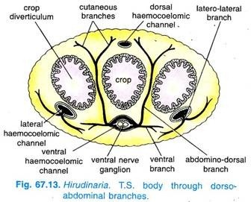
The haemocoelomic system consists of four longitudinal haemocoelomic channels, their branches, and some networks formed by capillaries. The longitudinal haemocoelomic channels are one dorsal channel, one ventral channel, and two lateral channels.
The haemocoelomic fluid flows from posterior to anterior side in the dorsal and lateral channels, and it flows from the anterior to posterior side in the ventral channel. All four channels are joined to each other in the posterior region. The dorsal and ventral channels are distributing channels, the lateral channels are both distributing and collecting channels.

Longitudinal Channels and their Branches:
1. Dorsal Channel:
The dorsal channel runs mid-dorsally below the body wall and above the alimentary canal. It has a thin wall, which is non-contractile being made of connective tissue and coelomic epithelium. In each segment the dorsal channel gives off two pairs of dorso-laterals taking the haemocoelomic fluid to the dorsal and dorso-lateral regions of body wall and several dorsointestinals going to the alimentary canal.
The dorsal channel bifurcates in the twenty-second segment and these two branches join the ventral channel posteriorly. Anteriorly the dorsal channel forms a network above the alimentary canal from the sixth to the first segment. In the dorsal channel there is no valve and haemocoelomic fluid flows behind forwards.
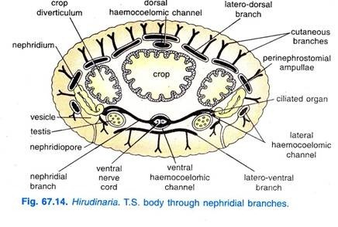
2. Ventral Channel:
The ventral channel, like the dorsal channel, has non-contractile thin wall being made of connective tissue and coelomic epithelium. It lies mid-ventrally below the alimentary canal extending from the anterior to the posterior end. It is broad and encloses the central nervous system within it.
It gives off two pairs of branches in each segment, the first branch or cutaneous branch divides on each side into two branches, a ventral branch going to the ventral body wall, and an abdomino-dorsal branch which passes vertically upwards to the dorsal body wall.
The second branch of the ventral channel in commisures of the lateral haemocoelomic channels, each segment is a pair of nephridial branches, each nephridial branch runs outwards and enlarges into a perinephrostomial ampulla which encloses the ciliated organ.
The nephridial branch is found only in eleven segments which contain testes, these branches take the haemocoelomic fluid to nephridia, body wall and ciliated organs around which they form bag-like perinephrostomial ampullae. Like dorsal channel, the ventral channel has no valve but haemocoelomic fluid flows from anterior to posterior side of the body.
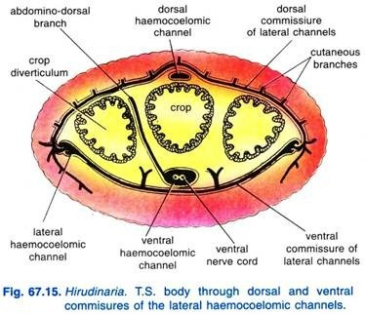
3. Lateral Channels:
The lateral channels run symmetrically one on each side of the alimentary canal. They are large in diameter and become even larger in the posterior third of the body. The lateral channels have contractile muscular walls and they contain valves which allows the haemocoelomic fluid to flow from behind forwards only.
A lateral channel gives out one branch and receives two branches in each segment. It gives out a latero-ventral branch which bifurcates into an anterior and a posterior branch and each joins its fellow of the opposite side mid-ventrally to form a rhomboidal swelling, i.e., ventral commissure of laterals in each segment, then they take the haemocoelomic fluid to the alimentary canal, nephridia and reproductive organs.
Each lateral channel receives a latero-Iateral branch in each segment from the skin and nephridium of its side, and a latero-dorsal branch from the skin and the viscrea; the latero-dorsals of both lateral channels are connected together dorsally above the dorsal channel by dorsal commissure of the laterals.
Thus, the branches of the lateral channels supply the haemocoelomic fluid to the skin, nephridia, reproductive organs, alimentary canal and lower body wall; and they collect the haemocoelomic fluid from all parts, i.e., from upper and lower body wall, skin, alimentary canal, nephridia and reproductive organs.
Anteriorly the lateral channels break up into capillaries in fifth segment, and posteriorly they join the ventral channel.
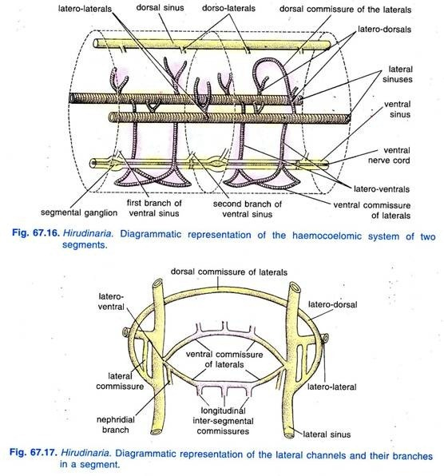

Capillary System of Hirudinaria Granulosa:
The four channels not only communicate with each other but they form capillaries in the skin, muscles and botryoidal tissue. This capillary system (Fig. 67.18) has three main sets, a set of botryoidal capillaries forming a network in the botryoidal tissue.
This condition of communication with capillaries of botryoidal tissue is unique, it may be compared to vertebrates in which the lymphatic system communicates both with the coelom and the blood system. The second part of the capillary system is an intramuscular set of capillaries in the muscles. The third is a set of cutaneous capillaries in skin.
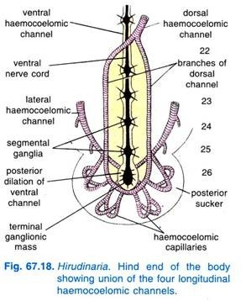

Course of Blood Circulation in Haemocoelomic System of Hirudinaria Granulosa:
Of the four longitudinal channels, the fluid in the dorsal and two lateral channels moves from behind forwards, while in the ventral it runs from anterior to posterior end of the body. The dorsal and ventral are the distributing channels, while the laterals are collecting as well as distributing channels. All the channels are in direct communication with one another at the posterior end.
The dorsal channel supplies fluid to the dorsal and dorso-lateral parts of the body wall and the entire alimentary canal, from where it is collected by latero-dorsals, which carry the fluid to the lateral channels.
The ventral channel supplies the fluid to the ventral, ventro-lateral and median dorsal region of the body wall, ciliated organs, nephridia and the atrium. From all these parts the fluid is collected by the latero-lateral branches of the lateral channels.
Lateral channels supply the fluid to the nephridia, genital organs, gut and ventral body wall through the latero-ventrals and is collected back through the latero-lateral and latero-dorsal branches.
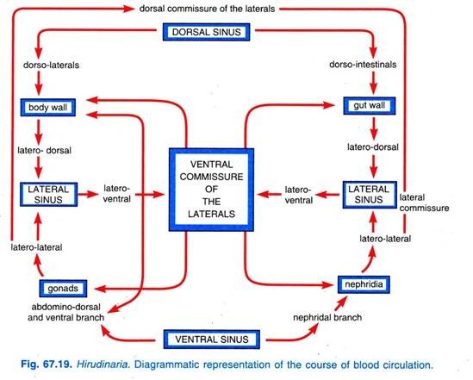

8. Respiratory System of Hirudinaria Granulosa:
There are no special respiratory organs in Hirudinaria. In addition to its primary role of a protective covering, the skin also serves a respiratory function. It is provided with a rich supply of haemocoelomic fluid in an extensive system of capillaries and capillary loops, which penetrate into the spaces between the inner ends of the epidermal cells.
The epidermis acts as a permeable membrane through which the CO₂of the haemocoelomic fluid in the capillary loops is exchanged for the O₂ dissolved in water. Leeches live in water or in damp soil, and, thus, the skin is always kept wet by the surrounding water, while the mucus secreted by the epidermal slime glands also prevents it from drying on exposure to the atmosphere.

9. Excretory System of Hirudinaria:
The excretory system consists of segmentally arranged seventeen pairs of nephridia lying in segments from sixth to twenty-second.
The first six pairs of nephridia are situated in the pre-testicular segments (sixth to eleventh), while the remaining eleven pairs are situated in the testicular segments (twelfth to twenty-second). The nephridia lying in the pre-testicular segments and the testicular segments are termed pre-testicular and testicular nephridia respectively.
Testicular Nephridium:
A typical testicular nephridium (Fig. 67.20) has a horse-shoe-shaped structure.
Beginning with the inner coelomic end a typical testicular nephridium consists of six parts, viz.,:
(i) Ciliated organ
(ii) Initial lobe
(iii) Apical lobe
(iv) Main lobe
(v) Inner lobe
(vi) Vesicle-duct and the vesicle
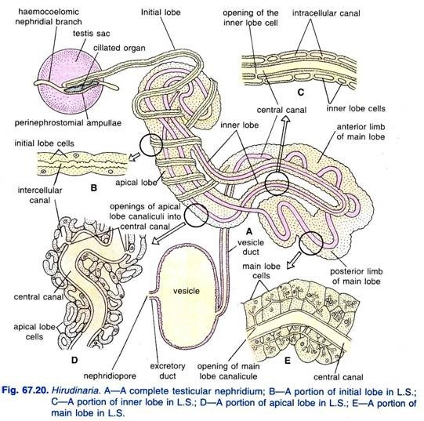
(i) Ciliated Organ:
A ciliated organ is completely enclosed within the perinephrostomial ampullae which is a dilation of the haemocoelomic system. A ciliated organ has a central reservoir which is perforated, around which are innumerable ciliated funnels. The reservoir is a more or less spongy structure with an outer wall formed of single layer of cells and a central mass consisting of connective tissue cells which manufacture corpuscles.
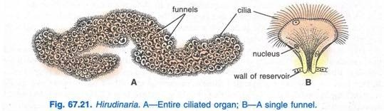
Each ciliated funnel is like an ear-lobe, with about one-fourth of its margin incomplete along one side and is covered with outwardly directed cilia on its outer margin and inner surface. The ciliated organ manufactures coelomic amoeboid corpuscles.
Ciliated organs are joined to nephridia in the embryo, but in the adult animal they have no connection with nephridia.
This shows that originally the ciliated organ belonged to a nephridium, but in the adult having no connection with the nephridium. It is not excretory but has become a part of haemocoelomic system for making corpuscles. Ciliated organs correspond to coelomoducts of Polychaeta and not to nephrostomes of nephridia.
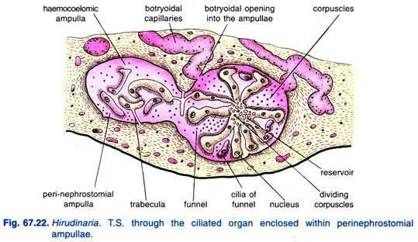
(ii) Initial Lobe:
The initial lobe or the testicular lobe is a long and slender cord-like structure which twines around the apical lobe, then ends blindly in front close to the perinephrostomial ampullae and its posterior end joins the main lobe. It consists of a single row of elongated hollow cells placed end to end having the intracellular canal which gives off several diverticula in each cell.
(iii) Apical Lobe:
The posterior limbs of the main lobe pass forward to form a stout lobe, the apical lobe, which lies in the anteroposterior position beneath the gut. The apical lobe is fairly stout and its anterior end is bent on itself like the handle of a walking stick. The cells of the apical lobe are much larger than those of the initial lobe and are traversed by numerous regular intracellular canals.
(iv) Main Lobe:
The main lobe, forming the horse-shoe proper, lies in a ventrolateral position between the adjacent diverticula of the crop. It consists of two unequal limbs, one longer and anterior in position, and the other smaller and posterior. The cells of the main lobe are the largest in the nephridium and are polyhedral in shape.
(v) Inner Lobe:
The inner lobe is narrow and lies all along the inner concavity of the main lobe and also runs forwards along the outer border of the apical lobe for about half of its length. Its cells are long and tubular, the lumen in each cell is very large and makes a big excavation in the cell, cytoplasm contains a small nucleus.
(vi) Vesicle Duct and Vesicle:
From the lower end of the anterior limits of main lobe arises a thin vesicle duct which passes over and joins a large thin-walled oval bag called vesicle or bladder. Bhatia (1940) has described that the lining of bladder is ciliated but a later worker B. Dev is of the view that the so called cilia are nephridial micro-flora consisting of non-motile bacteria ranging from 2.8 µ to 7 µ in length.
From the vesicle emerges a short excretory duct which opens externally by a rounded aperture, the nephridiopore in the last annulus of the segment in which the nephridium lies. A nephridium is made of a cord of cells, the initial lobe has no canal but an intercellular ciliated canal starts from the apical lobe, goes into the inner lobe, then passes through the main lobe to enter the vesicle duct.
Pre-testicular Nephridia:
The first six pairs of nephridia, called pre-testicular nephridia, resemble the testicular nephridia in structure; but they lie in the segments from sixth to eleventh in which testis sacs, perinephrostomial ampullae, and ciliated organs are absent. The initial lobes of these nephridia end loosely in the general connective tissue on either side of the ventral nerve cord.
Central Canal of Nephridium:
The cells of initial lobe, apical lobe and inner lobe possess intracellular canals, all these open into a central canal originating from the anterior part of apical lobe.
The central canal is, thus, a long continuous passageway traversing through the different lobes of nephridium and finally enters the vesicle duct near anterior limb of the main lobe. Thus, this canal carries the excretory products secreted by the glandular cell masses of the nephridium and finally discharges into the vesicle through vesicle duct.

Physiology of Excretion in Hirudinaria Granulosa:
The ciliated organ is completely separated from the nephridium in the adult. It has no excretory function but manufactures coelomic corpuscles of the haemocoelomic system. The nephridium proper is truly excretory in function and serves to eliminate excess of water and nitrogenous waste. Nitrogenous waste consists mainly of ammonia and small quantities of urea, hence, leech is ammonotelic.
Nephridia act as excretory as well as osmoregulatory organs. The nephridium is richly supplied with branches of haemocoelomic channels and the gland cells separate waste products from the haemocoelomic fluid. The excretory fluid is finally collected in the vesicle of nephridium to be discharged through the nephridiopore.
As referred to, nephridium is also osmoregulatory in function because it is related to maintain water balance in the body; the osmotic pressure of body fluid is always higher than the surrounding water, hence, water enters its body continuously. The nephridia, however, removes excess water.
The leeches are also said to possess a special mechanism in their epidermis for taking in Na and CI ions to compensate those lost in the metabolism. This helps in maintaining a constancy in the body fluid osmotic pressure. Several workers have also assigned an excretory function to the botryoidal tissue, the capillaries of which are in communication with the haemocoelomic fluid.

10. Nervous System of Hirudinaria Granulosa:
The nervous system is of usual annelidan type except there is a fusion of ganglia at the anterior and posterior ends.
It consists of three parts:
(1) Central nervous system
(2) Peripheral nervous system
(3) Sympathetic nervous system

1. Central Nervous System:
The central nervous system consists of five parts, viz.,:
(i) A pair of cerebral ganglia,
(ii) A pair of peripharyngeal connectives,
(iii) A sub-pharyngeal ganglionic mass,
(iv) A ventral nerve cord, and
(v) Terminal ganglionic mass. The entire central nervous system is enclosed within the ventral haemocoelomic channel.
A pair of fused cerebral ganglia or supra-pharyngeal ganglia form a small brain above the pharynx in the fifth segment. The brain has shifted back due to a reduction in size of prostomium.
From the brain, peri-pharyngeal connectives (one on either side of the pharynx) arise and join a sub-pharyngeal ganglionic mass lying below the pharynx in the fifth segment, this is formed by fusion of four pairs of ganglia. Thus, the cerebral ganglia and sub-pharyngeal ganglionic mass represent the ganglia of first five segments of the body.
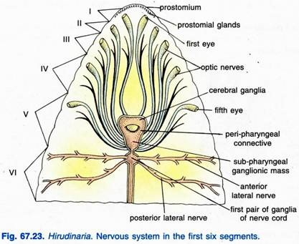
A double ventral nerve cord, being covered in a protective sheath called neurilemma, runs along the mid-ventral line, from the sub-pharyngeal ganglionic mass to the terminal ganglionic mass lying within the posterior sucker. It has twenty-one double ganglia, each lying within the first annulus of its own somite, from the sixth to the twenty-sixth segment.
The terminal ganglionic mass is a large ovoid body composed of seven pairs of ganglia fused together, each pair belonging to a segment of, the sucker.

2. Peripheral Nervous System:
It consists of paired nerves given off from the various ganglia of the central nervous system, which innervate all parts of the body.
A pair of stout nerves arises from the brain which runs forward to supply the first pair of eyes, the prostomium and the roof of the buccal chamber.
The subpharyngeal ganglionic mass gives out four pairs of nerves which go to the second, third, fourth and fifth pairs of eyes and also to segmental receptors of the first five segments, roof of the buccal cavity and the muscles of body wall. From each ganglion of ventral nerve cord arise two pairs of stout nerves, the anterior laterals and posterior laterals.
The anterior laterals arise from the anterior part of the ganglion, branch and innervate the vas deferens, nephridium, the nephridial vesicle, muscles of body wall, ventral nerve receptors and two outer dorsal receptors of their own side.
The posterior laterals arise from the posterior part of the ganglion just behind the anterior laterals.The posterior laterals branch and innervate the viscera, median dorsal region of body wall and the central pair of the dorsal segmental receptors. The terminal ganglionic mass sends off several nerves supplying the receptor organs and other structures found within the posterior sucker.

3. Sympathetic Nervous System:
It forms extensive nerve plexuses beneath the epidermis, within the muscle layers of body wall and on the wall of the alimentary canal. It is connected, on the one hand, with certain cells on both sides of the peripharyngeal connectives and, on the other, with multipolar ganglion cells, irregularly distributed over the entire alimentary nerve plexus.

11. Sense Organs of Hirudinaria Granulosa:
The sense organs or receptors of leech consist of specially modified epidermal cells.
There are four types of receptors:
(i) Free nerve endings
(ii) Annular receptors
(iii) Segmental receptors
(iv) Eyes

(i) Free Nerve Endings:
The free nerve endings are found all over the body, between the epidermal cells, with their ganglion cells lying beneath the epidermis. They are probably chemoreceptors.

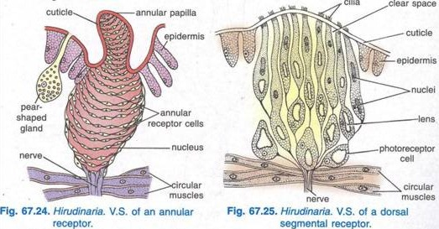

(ii) Annular Receptors:
These are arranged in a line across the middle of each annulus of a segment. Each annulus of the body bears 36 very minute annular receptors, 18 on the dorsal side and 18 on the ventral side. Each receptor projects as a small papilla and consists of many flat overlapping cells which receive nerve fibres from the lateral branches. Annular receptors are tactile organs or tango receptors.

(iii) Segmental Receptors:
These are small whitish patches elevated on the elliptical papillae borne upon the first annulus of everybody segment. They lie in four pairs on the dorsal surface and three pairs on the ventral surface in each segment. Each receptor consists of a group of long slender cells, 10 to 15 in number which are separated from one another by clear spaces.
There are 5 to 10 long, slender tactile cells, separated from one another and provided with five hair-like processes at their outer free ends.
The photoreceptor or light perceiving cells, found only in the dorsal receptors, contain a crescentic hyaline substance, the optic organelle or lens, in their cytoplasm. Each receptor receives a nerve branch from one of the lateral nerves and functions as tango receptors and photoreceptors.

(iv) Eyes:
There are five pairs of eyes lying in a semicircle of black spots on the dorsal surface of the anterior sucker, one pair in the first annulus of each of the first five segments.
Each eye is cylindrical or cup-like in shape with its long axis perpendicular to the body surface. Each eye consists of a long pigmented cup covered externally by transparent epidermis and cuticle forming a cornea. Inside the cup are refractive cells arranged in several longitudinal rows.
Each refractive cell contains a crescentic hyaline substance, the optic organellae or lens surrounded by a very thin peripheral layer of cytoplasm containing a small rounded nucleus. An optic nerve enters each eye basally and runs along its median axis distributing branches to all photoreceptor cells.
All the eyes are not of equal size; the first and second pairs are the largest, while the remaining pairs are comparatively smaller in size, the fifth pair being the smallest.
The eyes are differently directed and each eye can receive the light only from one direction. It is not known whether the eyes are able to form images of external objects; probably they can distinguish light from darkness and enable the leech to locate the direction of the source of light.
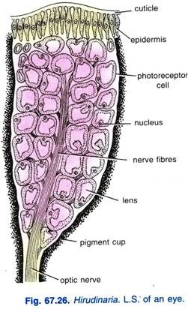
On the basis of their metameric arrangement and histological structure, Whiteman regards the eyes to be serially homologous with the segmental receptors.

12. Reproductive System of Hirudinaria:
Leeches are hermaphrodite (monoecious), i.e., each individual possesses a complete set of well differentiated male and female reproductive organs. Self-fertilisation does not occur. Cross- fertilisation, preceded by copulation, is being effected.

Male Reproductive Organs of Hirudinaria:
The male reproductive organs consist of:
(i) Testis sacs
(ii) Vasa efferentia
(iii) Vasa deferentia
(iv) Epididymis
(v) Ejaculatory ducts
(vi) Atrium
(i) Testis Sacs:
There are usually eleven pairs of testis sacs in segment twelfth to twenty- second, one pair in each segment, lying ventrally, one on either side of the ventral nerve cord. Each testis sac is small spherical coelomic sac, from the walls of which spermatogonia or sperm-mother cells are budded off. The spermatogonia float in the coelomic fluid within each testis-sac and develop into spermatozoa.
(ii) Vasa Efferentia:
From the posterior border of each testis-sac arises a short sinuous duct, the vas efferens, through which the mature spermatozoa are passed into the vas deferens. All the vasa efferentia of one side open into the common vas deferens of that side.
(iii) Vasa Deferentia:
They are a pair of slender longitudinal ducts running forward, from twenty-second to the eleventh segment, lying along the ventral body wall on either side of nerve cord. Each vas deferens is enclosed within a tubular coelomic space which contains amoeboid corpuscles similar to those of the haemocoelomic fluid.
(iv) Epididymis:
Each vas deferens, in the tenth segment, swells to form closely convoluted and compact mass, the epididymis or sperm-vesicle. The two epididymis serve to store the spermatozoa.
(v) Ejaculatory Ducts:
From the inner and anterior end of each epididymis arises a short narrow ejaculatory duct or ductus ejaculatorious.
(vi) Atrium:
It is a pyriform sac situated in the ninth and tenth segments, to which join the ejaculatory ducts of both the sides. The atrium is made of an anterior prostate chamber and a posterior penis sac. The prostate chamber possesses thick muscular walls covered over with several layers of unicellular prostate glands.
The penis-sac is an elongated muscular chamber and contains a tubular coiled penis which can be everted and is often seen protruding out through the male genital aperture on the ventral side of the second annulus of tenth segment.
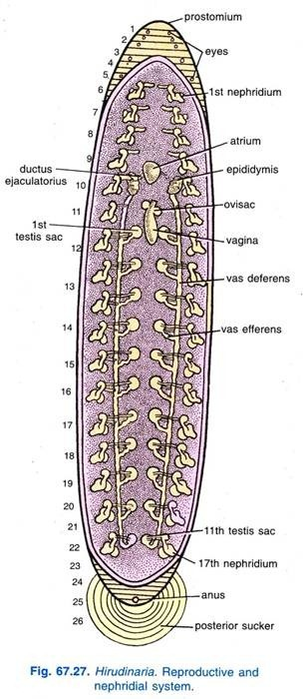
The spermatozoa produced in testis-sacs are stored in the epididymis. From the epididymis of each side the spermatozoa pass into the prostatic chamber where they are glued together by a secretion of the prostate glands to form bundles called spermatophores. The spermatophores pass into the narrow canal of the penis, through which they are transferred into vagina of other leech during copulation.
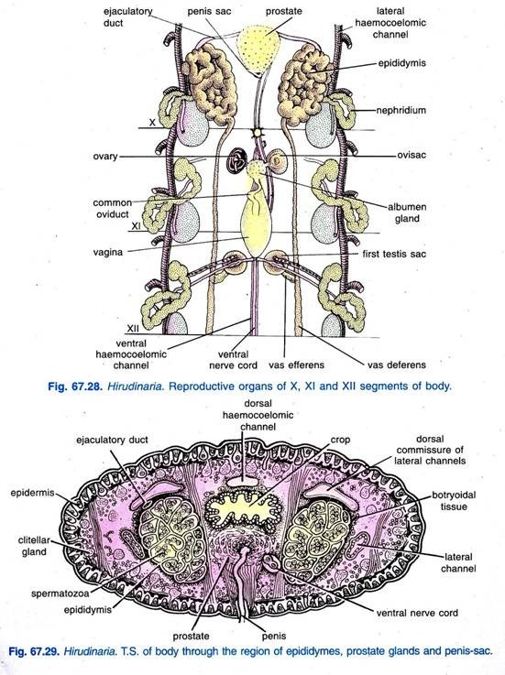

Female Reproductive Organs of Hirudinaria Granulosa:
The female reproductive organs consist of:
(i) A pair of ovisacs
(ii) A pair of oviducts
(iii) Common oviduct
(iv) Vagina
(i) Ovisacs:
There is a single pair of globular ovisacs enclosing coelomic spaces and an ovary in each, situated in the eleventh segment. Each ovary is a coiled nucleated cord from which ova are budded off; it terminates in club-like ends. The coiled ovaries remain floating in the haemocoelomic fluid enclosed within the ovisacs.
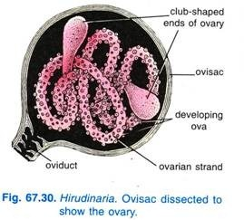
(ii) Oviducts:
From the base of each ovisac arises a short slender tube, the oviduct. The right oviduct passes beneath the ventral nerve cord.
(iii) Common Oviduct:
The oviducts of two sides unite to form a common oviduct which is like an S. The common oviduct lies in the eleventh segment. At the junction of oviducts is a mass of unicellular albumen glands opening into the common oviduct. The common oviduct opens into a pear-shaped muscular vagina.
(iv) Vagina:
The vagina is a large pear-shaped muscular bag lying in the posterior part of the eleventh segment. It increases in size during the breeding season and also becomes internally thrown into a large number of longitudinal folds.
It opens to the exterior through a mid-ventral female genital aperture in the second annulus of eleventh segment. The ova, budded off from the ovaries, pass through the oviducts into the vagina where they remain for some time.
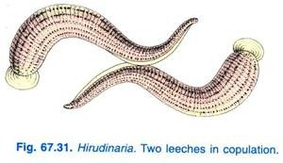

13. Copulation and Fertilisation in Hirudinaria Granulosa:
Copulation takes place in the months of March and April; during copulation two leeches come together by their ventral surfaces pointing in opposite directions, so that the male aperture of each is opposite the female aperture of the other. The penis of each is inserted into the vagina of the other and spermatophores are deposited, so that there is mutual insemination.
Copulation may occur on land or in water, it lasts for an hour after which the two worms separate. Fertilisation occurs in vagina, i.e., it is internal. The fertilised eggs are discharged through the female genital aperture into the cocoon (ootheca) where further development occurs.

14. Cocoon or Ootheca Formation in Hirudinaria Granulosa:
The cocoons (Fig. 67.32) of Hirudinaria are formed in April, May and June. The clitellum forms around segments nine to eleven during breeding season, its glands secrete a frothy girdle which hardens to form a cocoon, the clitellar glands secrete albumen into the cocoon used as nourishment by the developing embryo.
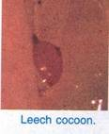
The fertilised eggs are extruded into the cocoon. The leech wriggles out backwards from the cocoon, the two ends are closed by polar plugs secreted by the prostomial glands. The cocoon is an amber-coloured barrel 30 mm x 15 mm in size. It has an outer spongy layer and an inner tough chitinous layer. The cocoons are always laid in moist mud but never in water. Cocoon formation takes about six hours.
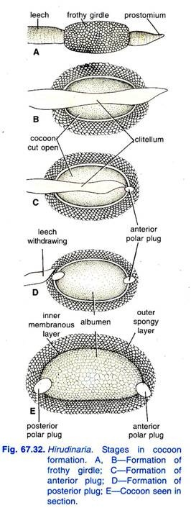

15. Development of Hirudinaria Granulosa:
Development of young proceeds within the cocoon. In each cocoon one to twenty-four embryos develop and swim in the cocoon feeding on albumen, they finally escape from the cocoon. Development is direct, there is no larva, and it is completed in about fourteen days.

16. Parasitic Adaptations in Hirudinaria Granulosa:
Hirudinaria, the common Indian cattle leech, leads a parasitic life as it feeds on the blood of cattle and man. For parasitic mode of life, there are a number of adaptive features in it.
However, some of these features are as under:
1. Its long, flattened, limbless swift swimming nature and slimy body is well suited for its aquatic life.
2. Its slimy body covering protects it from desiccation; reduces friction in water during locomotory activity and also facilitates respiration through the skin.
3. Its preference to live in shallow waters of the pond, tank, lake and stream ensures food as the catties and man frequently visit these water reservoirs for drinking or bathing. It also provides concealment under weeds, logs and stones lying at the bank of these water reservoirs.
4. Anterior and posterior suckers are the organ of attachment; particularly posterior sucker is much more powerful and muscular.
5. Since it is sanguivorous in habit, hence, it must attach itself to the body of the host. So, its suckers help in doing so.
6. It possesses denticulated jaws in the buccal cavity; the jaws make wounds on the body of victim so that victim’s blood vessels are exposed and blood starts oozing out.
7. It possesses a muscular suctorial pharynx; the oozing blood from the victim’s body is sucked by the pumping action of the pharynx.
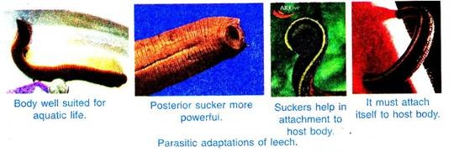
8. Its saliva contains hirudin, an anticoagulant, that prevents blood clotting so that the leech may suck the blood for longer duration, as getting a host is a chance.
9. Its ten chambered crop with caeca help in storing the blood; it is believed that leech can suck blood several times more of its own weight in a single meal. So, this blood is stored in crop and caeca.
10. Its one full meal is supposed to be enough for many months and even for a year because the process of digestion is very slow.
11. Since special respiratory organs are not found in leech, hence, its skin is richly supplied by haemocoelomic capillaries to ensure proper exchange of gases from the surroundings.
12. Its well developed receptors provide better chances of survival.
13. Its hermaphroditic sexuality has doubled the rate of reproduction as all individuals are capable of laying eggs in contrast to only 50 per cent individuals of unisexual forms.
14. Development occurs in ootheca or cocoon; the cocoon provides protection to developing young ones.
15. A short span of developmental period, i.e., a fortnight, and formation of several (up to 24) individuals in a single cocoon ensure to maintain its regular population.

